Sales Analytics Database & SQL Reporting System

Objective
The objective of this project is to design and implement a SQL-based sales analytics system that stores customer, product, order, and regional data. Using SQL queries, the project generates business insights such as total revenue, monthly trends, best-selling products, and region-wise performance.

Introduction
A company must analyze sales performance to understand customer behavior, product demand, and revenue trends. A structured SQL database helps store sales data efficiently and enables analytical reporting using queries. This project demonstrates how SQL can be used to build a clean sales database and generate meaningful insights.

Database Design

ER Diagram
Write the relationships:
- One region has many customers
- One customer has many orders
- One order has many order items
- One product appears in many order items

Tables Used
List of tables:
- Regions
- Customers
- Products
- Orders
- Order_Items
SQL Schema


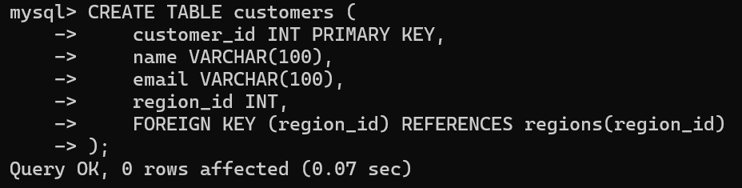
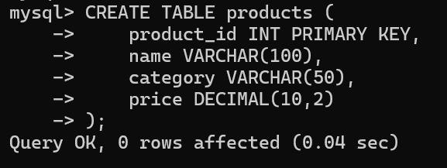
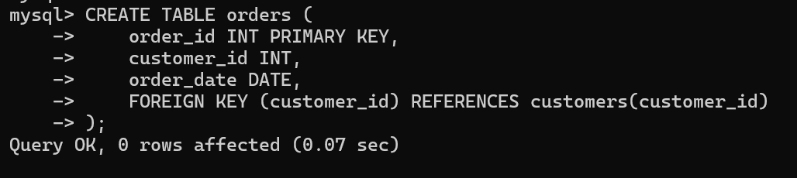
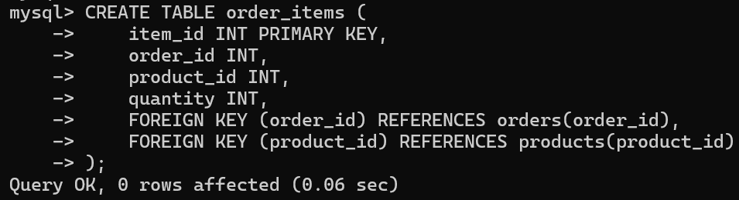

Sample Data
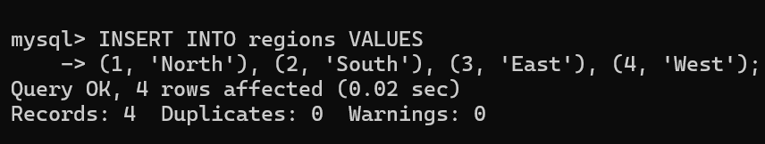
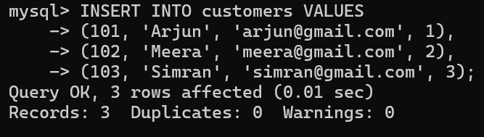
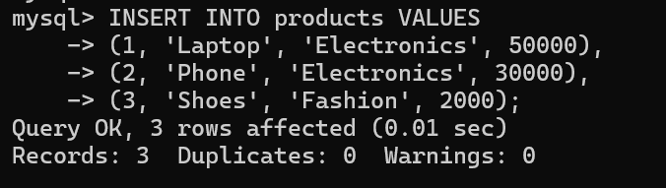
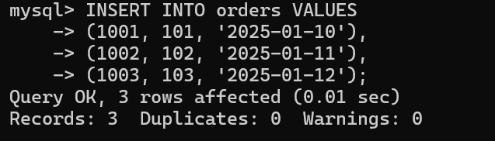
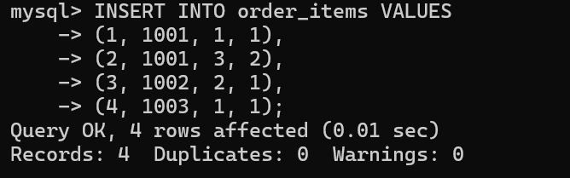
SQL Queries for Analytics
- Total revenue
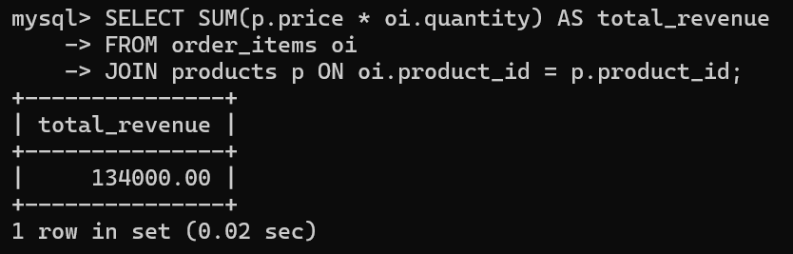
- Monthly revenue
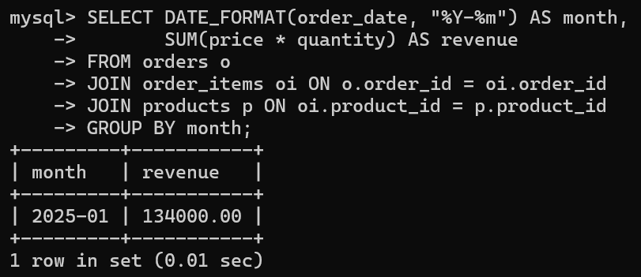
- Top 5 Best-Selling Products
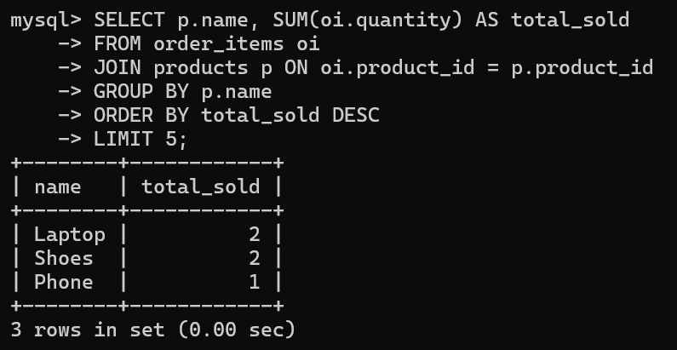

- Region-wise Revenue
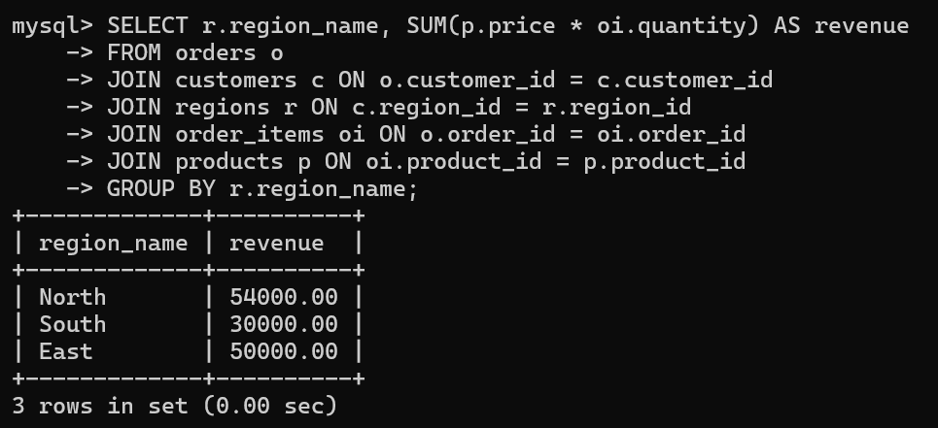
- Customer Purchase Summary
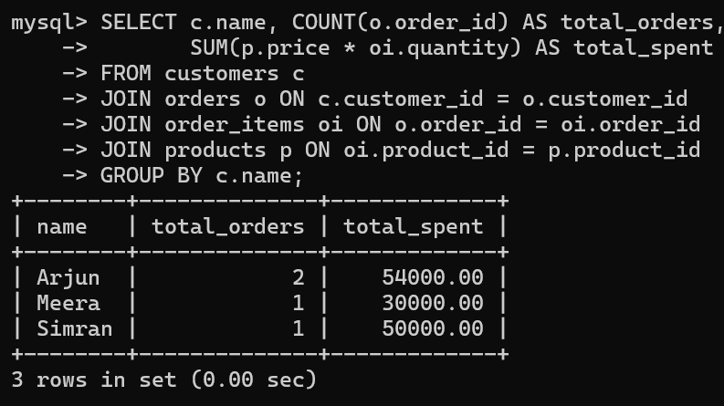

Conclusion
This project demonstrates how SQL can be used to design a functional sales analytics system. The database structure efficiently stores sales data and supports analytical queries that reveal valuable business insights. Using SQL, companies can monitor performance, identify trends, and make data-driven decisions.

